# **Overview**

CFPB has implemented Zscaler, a Zero Trust Architecture (ZTA). The purpose of this guide is to provide instructions for Technicians to troubleshoot and resolve incidents.

## Zscaler Service Components

* **Zscaler Client Connector (ZCC)** connects users to CFPB, non-CFPB, Wi-Fi, and cellular.
* **Zscaler Private Access (ZPA)** allows access to CFPB apps and services from outside CFPB.
* **Zscaler Internet Access (ZIA)** protects end-user internet traffic to external sites.
* **Zscaler Digital Experience (ZDX)** monitors CFPB device connectivity for issues.

## Private Access (ZPA) Connectivity Issues

**Keywords**:Zscaler,ZPA, access, connectivity, authentication, client, intranet, VPN

**Symptoms**:Authentication issues or access to CFPB internal apps, services, other resources.

**Error Message(s)**

Expand Image:

### **Level 1: Probing Questions**

* Have you rebooted your device recently? If yes, but this has not resolved the issue, proceed to Level 2: Resolution using Private Access Tools.

### **Level 2: Resolution using Private Access Tools**

1. Open ZCC by *right clicking* the **icon** in the taskbar.
2. Select **Open Zscaler** on Windows or **Open** on macOS.
3. *Navigate* to **Private Access** on the left menu.

Expand Image:

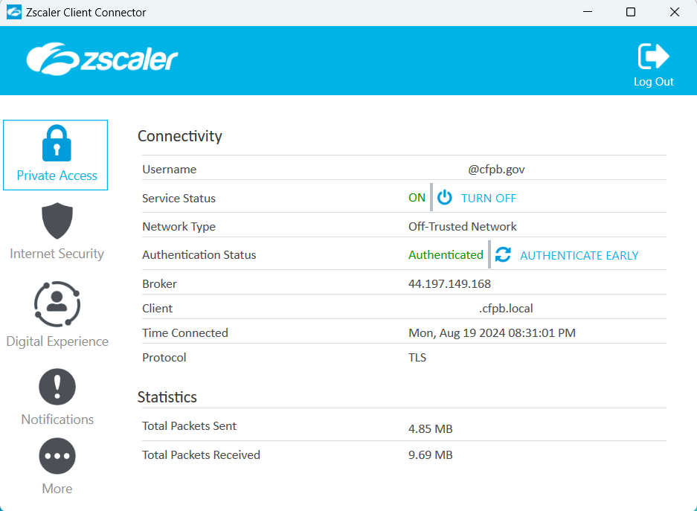

1. Under**Connectivity**, check the following:

* **Username:** Confirm CFPB email address is for the user.
* **Service Status:** **ON**.
* **Network Type:** Connected to Trusted / Off-Trusted Network* *Traffic through Zscaler.
* **Authentication Status:** Authenticated

**Note:** *Click* **Authenticate Early** to reauthenticate ZPA before authentication expires.

* **Broker:** Displays the IP address of the server to which your traffic is being forwarded.
* **Client:** Confirm local IP address on user’s device, ending in .fcpb.local
* **Time Connected:** Is the last login time recent?
* **Protocol:**  TLS.

1. *Click* **Turn Off**  to toggle the service off. This turns off the Zscaler Tunnel (Z-Tunnel) and disables the ZPA service while remaining logged into the app.

**Pause for 30 seconds.**

1. *Click* **Turn On**  to toggle the service on.

**Note:** The Private Access service is disabled until you *click* **Turn On**.

1. ***Resolving Zscaler Client Connector (ZCC) App Issues***
2. If these steps do not resolve the issue, have the user **Log out** and **Log in** with the button in the corner.

## Resolution using Zscaler Client Connector (ZCC) Tools

**Keywords**:Zscaler,ZCC, access, connectivity, authentication, client, internet, slowness

**Symptoms**:Issues with access or slowness to external websites and/or internal resources.

### **Level 1: Probing Questions**

* Have you rebooted your device recently? If yes, but this has not resolved the issue, proceed

**Troubleshooting**:In the **More…** menu, under **Troubleshoot**, use the following:

#### **Restart Service**:

*Click* Restart Service.

**Note:** Restarting the app doesn't affect security enforcement. If the error persists, try Resolution 2.

#### **Repair App**:

**Note:** Zscaler recommends trying this option before reporting an issue.

*Click* Repair App.

**Note:** Attempts to repair the app by reinstalling app drivers and services. This option is only available for Windows.

#### **Repair with command prompt.**

## Zscaler Support for after hours, weekends and holidays

These are the steps to take if incident occurs after business hours starting at 5 pm until 6 am the next business day.

### Tier I will escalate the ServiceNow Incident to the Zscaler Support Group and initiate an email from the [servicedesk@cfpb.gov](mailto:servicedesk@cfpb.gov) mailbox to request to DOJ to resolve.

* + [DOJ.Service.Desk@usdoj.gov](mailto:DOJ.Service.Desk@usdoj.gov)
* [DOJ.SharedServicesEngineering@usdoj.gov](mailto:DOJ.SharedServicesEngineering@usdoj.gov)
* [ZTNAZscalerImplementation@cfpb.gov](mailto:ZTNAZscalerImplementation@cfpb.gov)

### **NOTE:** If the CSR is due to a critical issue and/or service outage, please call the service desk and request immediate support and describe the critical / emergency nature of the issue.

### The DOJ Service Desk has playbooks to execute to contact the DOJ Engineering Team to engage in critical issue resolution and/or service restoration.

**Phone: 202.616.7100**